C:\Users\warre\OneDrive\d600-statistical-data-mining>git log --oneline --date=short --pretty=format:"%h %ad %s"
988a135 2025-05-26 Finished each requirment listed in C2 to D4
28d3630 2025-05-26 Add D600 Task 1 notebook
9da98ff 2025-04-28 Upload New File
2431eed 2025-02-18 Re added readme file
fa5a025 2025-02-18 Revert "readme"
c064b9e 2025-02-12 Delete D212Task3FinalCode.ipynb
7af3961 2025-01-29 Edit D212Task3FinalCode-import file.ipynb
de57125 2025-01-29 Merge branch 'keiona.middleton-main-patch-69912' into 'main'
3bfe10b 2025-01-29 Upload New File
47f2e00 2024-05-09 readme

B. Describe the purpose of this data analysis by doing the following:
1. Propose one research question that is relevant to a real-world organizational situation captured in the provided dataset that you will answer using multiple linear regression in the initial model.
What are the key factors that influence housing prices in the dataset, and how can these factors be used to predict housing prices?
2. Define one goal of the data analysis. Ensure that your goal is reasonable within the scope of the scenario and is represented in the available data.

The goal of this analysis is to build a multiple linear regression model to predict housing prices based on relevant features such as square footage, number of bedrooms, location, etc. and identify the most significant predictors.

C. Summarize the data preparation process for multiple linear regression analysis by doing the following:
1. Identify the dependent and all independent variables that are required to answer the research question and justify your selection of variables.
Dependent Variable:
Price: The housing price is the variable we aim to predict.
Independent Variables:
SquareFootage: Larger homes tend to have higher prices.
NumBathrooms: More bathrooms may increase the price.
NumBedrooms: More bedrooms may increase the price.
CrimeRate: Lower crime rates may increase the price.
SchoolRating: Higher school ratings may increase the price.
AgeOfHome: Newer homes may have higher prices.
DistanceToCityCenter: Proximity to the city center may increase the price.
LocalAmenities: More amenities may increase the price.
TransportAccess: Better transport access may increase the price.

2. Describe the dependent variable and all independent variables from part C1 using descriptive statistics (counts, means, modes, ranges, min/max), including a screenshot of the descriptive statistics output for each of these variables.
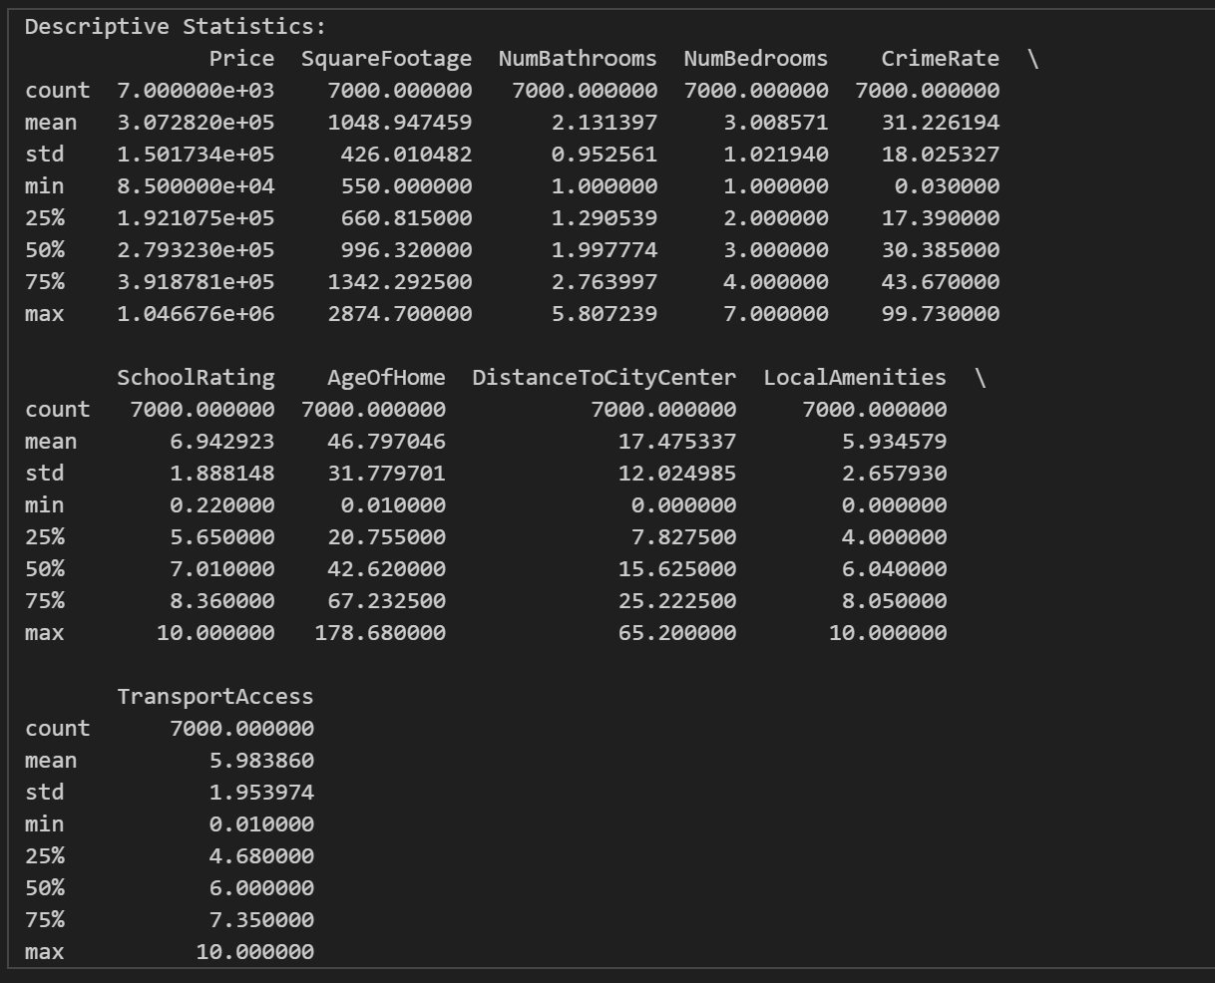
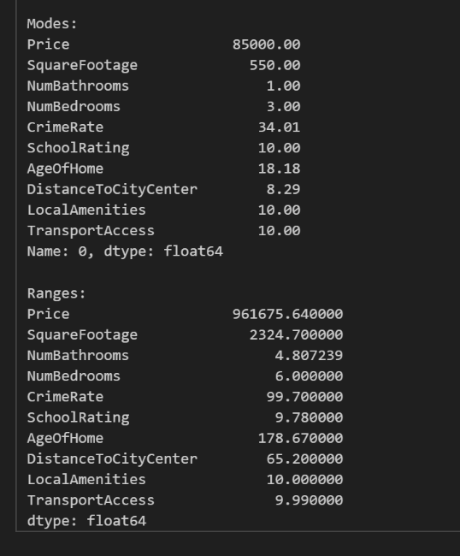
3. Generate univariate and bivariate visualizations of the distributions of the dependent and independent variables from part C1, including the dependent variable in the bivariate visualizations.

D. Perform the data analysis and report on the results by doing the following:
1. Split the data into two datasets, with a larger percentage assigned to the training dataset and a smaller percentage assigned to the test data set. Provide the files.
The data is split into 80% training and 20% test datasets

Note: The datasets should include only those variables identified in part C1.

2. Use the training dataset to create and perform a regression model using regression as a statistical method. Optimize the regression model using a process of your selection, including but not limited to, forward stepwise selection, backward stepwise elimination, and recursive selection. Provide a screenshot of the summary of the optimized model or the following extracted model parameters:
• adjusted R2
• R2
• F statistics
• probability F statistics
• coefficient estimates
• p-value of each independent variable
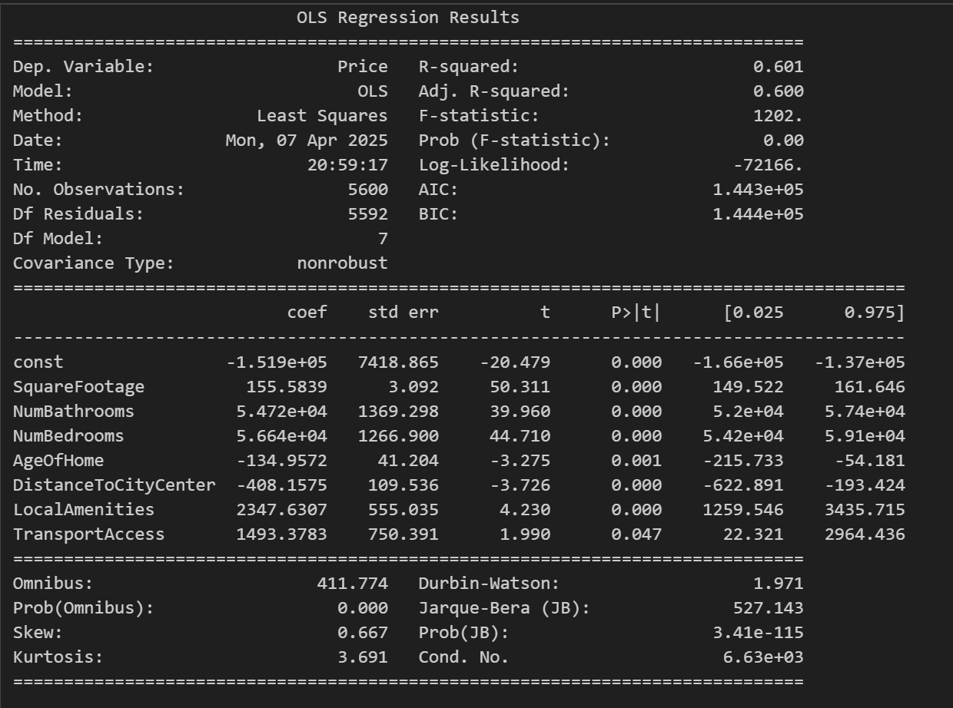
3. Give the mean squared error (MSE) of the optimized model used on the training set.
Training MSE: 9138985124.62064
4. Run the prediction on the test dataset using the optimized regression model from part D2 to give the accuracy of the prediction model based on the mean squared error (MSE).
Test MSE: 9111593899.356018
Note: The prediction run on the test dataset must use only the variables identified in the optimized regression model in part D2.

E. Summarize your data analysis by doing the following:
1. List the packages or libraries you have chosen for Python or R and justify how each item on the list supports the analysis.
pandas: Used for data manipulation, cleaning, and preparation. Essential for handling tabular data and selecting relevant columns for analysis.
numpy: Used for numerical operations and calculations. Provides efficient array operations and mathematical functions.
matplotlib and seaborn: Used for creating univariate and bivariate visualizations. Helps visualize data distributions and relationships between variables.
statsmodels: Used for building and optimizing the regression model. Provides detailed statistical summaries, including p-values, R², and F-statistics.
scikit-learn: Used for splitting the dataset and calculating the Mean Squared Error (MSE). Provides tools for model evaluation and validation.

2. Discuss the method used to optimize the model and justification for the approach.

Backward Stepwise Elimination. This method starts with all independent variables and iteratively removes the variable with the highest p-value (greater than 0.05) until all remaining variables are statistically significant. Backward stepwise elimination ensures that only the most significant predictors are included in the model, improving interpretability and reducing overfitting.

3. Discuss the verification of assumptions used to create the optimized model.
Scatterplots of residuals vs. fitted values were checked to ensure no systematic patterns.Ensures the relationship between predictors and the dependent variable is linear.
A histogram of residuals was plotted to confirm a roughly normal distribution. Ensures the residuals are normally distributed, a key assumption for valid statistical inference.
Variance Inflation Factor was calculated to ensure no multicollinearity among predictors. Reduces redundancy and ensures the stability of coefficient estimates.

4. Provide the regression equation and discuss the coefficient estimates.

Regression Equation:
Price = -151900.00 + 1493.38 * TransportAccess + 2347.63 * LocalAmenities - 408.16 * DistanceToCityCenter - 134.96 * AgeOfHome + 54720.00 * NumBathrooms + 56640.00 * NumBedrooms + 155.58 * SquareFootageIntercept (const):
The baseline price is -151,900 when all independent variables are zero. This value is not meaningful in practice because it assumes unrealistic conditions such as zero square footage, bathrooms.
SquareFootage (155.58): For every additional square foot, the price increases by $155.58, holding all other variables constant.
NumBathrooms (54,720): For every additional bathroom, the price increases by $54,720, holding all other variables constant.
The coefficient for NumBedrooms is 56,640.00. This means that, holding all other variables constant, each additional bedroom is associated with an increase of $56,640 in the predicted home price
AgeOfHome (-134.96): For every additional year of the home's age, the price decreases by $134.96, holding all other variables constant.
DistanceToCityCenter (-408.16):
For every additional unit of distance from the city center, the price decreases by $408.16, holding all other variables constant.
LocalAmenities (2,347.63): For every additional unit of local amenities, the price increases by $2,347.63, holding all other variables constant.
TransportAccess (1,493.38): For every additional unit of transport access, the price increases by $1,493.38, holding all other variables constant.

5. Discuss the model metrics by addressing each of the following:
• the R² and adjusted R² of the training set
• the comparison of the MSE for the training set to the MSE of the test set
R-squared of 0.601 and Adjusted R-squared of 0.600 on the training set means, for R-squared (0.601): About 60.1% of the variation in home prices is explained by your regression model’s predictors. This indicates a moderate fit the model explains a majority, but not all, of the variance in the data. Adjusted R-squared (0.600), this value adjusts for the number of predictors in your model. It is very close to the R-squared, which suggests that most predictors in the model are meaningful and not just adding noise. The model explains a substantial portion of the variance in home prices, but there is still about 40% of the variance left unexplained, possibly due to factors not included in your model or random variation. This is typical for real-world data. The closeness of R-squared and Adjusted R-squared also suggests the model is not overfitting.
R²: Indicates the proportion of variance in Price explained by the predictors.
Adjusted R²: Adjusts R² for the number of predictors, penalizing the inclusion of irrelevant variables.
Training MSE: Measures the average squared error on the training dataset.
Test MSE: Measures the average squared error on the test dataset.
Training MSE: 9138985124.62064 and Test MSE: 9111593899.356018, this tells us that the model is not overfitting as these two values are very near to each other
6. Discuss the results and implications of your prediction analysis. , therefore the model trains well and performs similar on both the test and training model sets.
Larger homes with more bathrooms in areas with lower crime rates and higher school ratings tend to have higher prices.
Real estate organizations can focus on these factors when pricing or marketing properties.
7. Recommend a course of action for the real-world organizational situation from part B1 based on your results and implications discussed in part E6. For Pricing Strategy:

Emphasize properties with larger square footage, more bathrooms, and proximity to high-rated schools. Highlight low crime rates in marketing materials.

No sources were used.

